HOW TO USE 4.1 TASK CODE

1. Take a photo (make sure it’s in 1080p)
2. Put the image in the folder
3. Open up “image shit good”
4. Change the image directory in the second box

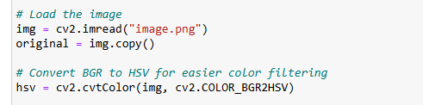

1. Run until you see the image as below

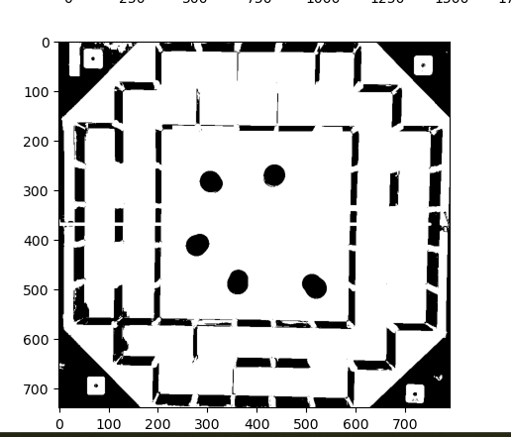

1. Fix any cropping issues using these parameters

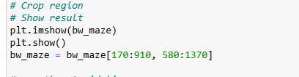

1. Run code until you see picture below and decide starting and ending goal points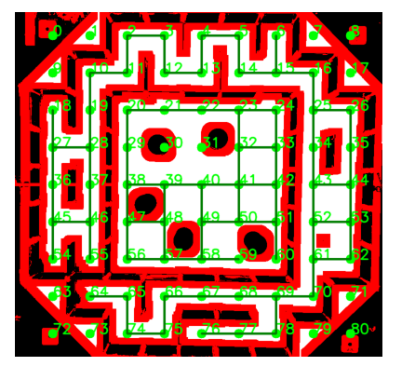
2. Change start, end and heading coordinates in top box

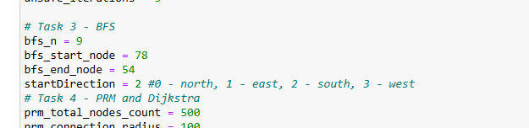

1. Output string looks like this

HOW TO USE 4.2 TASK CODE

1. Take a photo (make sure it’s in 1080p)
2. Put the image in the folder
3. Open up “image shit good – dijkstras3 – Copy”
4. Change the image directory in the second boxA screenshot of a computer program

   Description automatically generated
5. Run boxes and fix any potential cropping issues in the second box

1. Run boxes until you get to an image that looks like A screenshot of a game

   Description automatically generated
2. Decide your start and ending points and put them into the first box here where it says start and end node (todo: ill add directions later)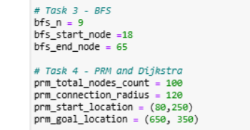
3. Run all the boxes and path should show up as A screenshot of a computer

   Description automatically generated